DocumentMall Export Connector

## Overview:

The DocumentMall Export Connector will allow Kofax Express to export a batch with an XML file that can be read by the Upload Agent to import batches into DocumentMall.

# Installation:

The DocumentMall Export Connector requires Kofax Express 2.0 and will run on any operating system that it supported by Kofax Express (<http://www.kofax.com/express/technical-specifications.asp> ). To install extract all files from the included zip file and execute setup.exe.

# Configuration:

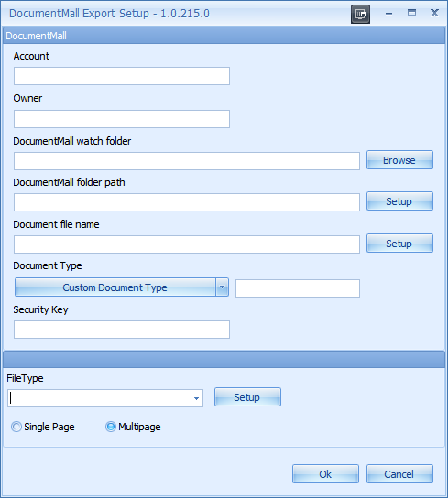

1. Account: This is the account name you are sending the documents to. This will populate the <docbase> tag.
2. Owner: This is the user sending the documents. This populates the <user> tag.
3. DocumentMall watch folder: The local folder where the Upload agent scans for new batches.
4. DocumentMall folder path: This is the path where the documents will be released in DocumentMall. This is a UNIX style folder.
5. Document file name: The name of the image files.
6. Document Type: The type of document being exported. This can be a static field or can be populated from an index field. These types need to be defined in DocumentMall first. Populates the <doctype> tag.
7. Security Key: The Permission Set Name (security key or ACL name) as defined in DocumentMall.